**Task-4**

**Gate Ways**

**Decision Gateways**

**The simplest gateway is called the Exclusive Gateway**. The outcome of the expression is a Boolean (true or false) outcome. The output of the decision is always that a single path is taken.

**Parallel Gateway:** It does not have an expression associated with it. When reached, all the paths associated are followed in parallel. Each followed path is termed a branch. To join the paths again, the same primitive can be used as a join.

**Inclusive Gateway:** Like the simple decision, there are expressions involved but in this case, control can flow from this primitive in one or more directions assuming multiple conditions evaluate to true.

**Event gateway:** This waits for a message to arrive but, if a message has not been delivered within a time period, the gateway times out and follows the path associated with the timer. This allows us to wait for a message and, if none has arrived, we can timeout.

**Task Overview:**

For our requirement use Decision Gate way. We will write condition for the field "Account Type" based on the value of that filed we will assign task to Verification Teams (Checker Teams).And assume each Team has 5 members .

If 'Saving Account' ---> Assign task to Verification Team1.

If 'Business Account' ---> Assign task to Verification Team2.

Condition1 : Always assign the tasks to the first three members of a team dynamically.(Use Team filter service)

Condition2 : Create the Child instance for the process, at a time two task has to create for two different activity and Complete the instance when both activity will be Finished (Parallel gateway).

**Implementation:**

* Drag and Drop a decision gateway in BPD and Map the sequence flow to Checker1 activity and Checker2 activity.
* Write a condition in Decision Gateway implementation section to forward the flow execution.

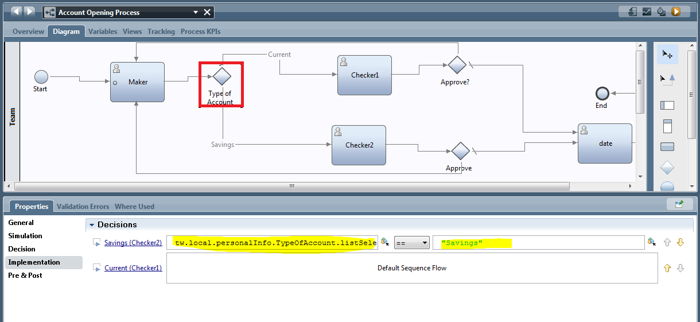

* Click on checker1 -> Assignments->Create a new Team filter service and then Implement the code to assign tasks to first 3 members of the group.

**var resultTeam=new tw.object.Team();**

**var resultTeam1=new tw.object.Team();**

**resultTeam1= tw.system.org.findRoleByName("tw_allusers");**

**resultTeam.members=new tw.object.listOf.String();**

**for(var i=0;i<3;i++)**

**{**

**resultTeam.members[i]=resultTeam1.allUsers[i].name;**

**}**

**tw.local.team=resultTeam;**

